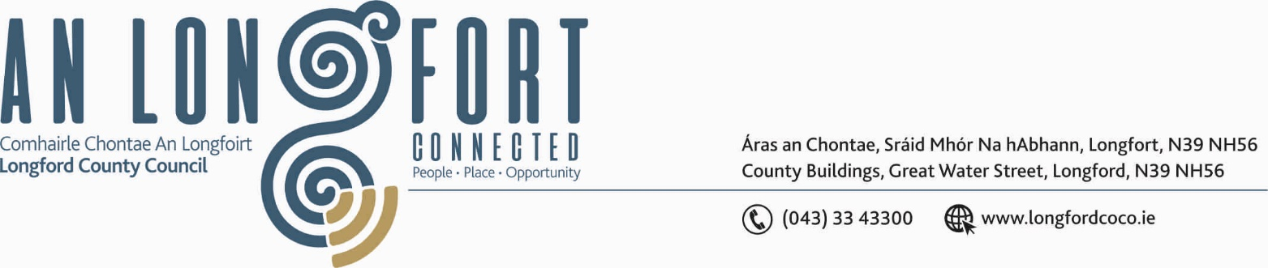

Please note the Presentation of the new Municipal District Chains of Office
will be held at 3.45 p.m. and the launch of the Leinster Fleadh will be held
at 6.30 p.m.

5u Aibrean 2017.

Chuig: Gach Ball don Chomhairle.

A Chomhairleoir,

Iarrtar ort bheith i láthair ag Cruinniú Míosuil Chomhairle Chontae Longfoirt a tionólfar i Seomra na Comhairle, Aras an Chontae, Longfoirt ar an Chéadaoin, 12u Aibrean 2017 ag 4.00 p.m chun gnó a dhéanamh d’réir an Chláir thíos.

You are requested to attend the Monthly Meeting of Longford County Council to be held in the Council Chamber, Aras an Chontae, Great Water Street, Longford, on Wednesday, 12th April 2017 at
4.00 p.m. to transact business, as set out on the Agenda.

Mise le meas,
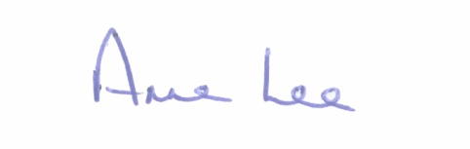

_______________
Anne Lee,
Meetings Administrator.

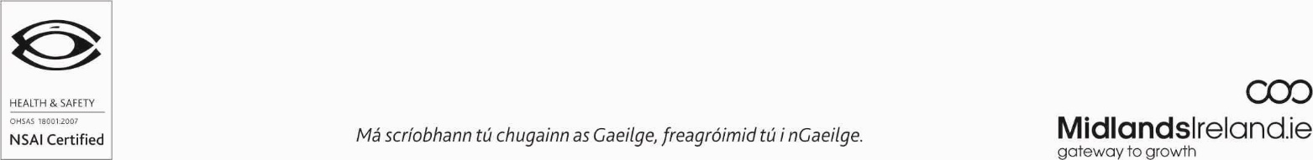

C L A R

Prayer before Meeting.

- Confirmation of Minutes of the following Meetings of Longford County Council –

- Committee Meeting held on the 1st February 2017.
- Monthly Meeting held on the 8th March 2017
– copies enclosed.

2. Matters arising from Minutes.

3. To note Chief Executive Orders. (Summary herewith)

4. To note Monthly Management Report - Report to follow.

5. To note adopted Minutes of Corporate Policy Group Meeting held on
8th February 2017 – copy enclosed.

6. Attendance of Jude O’Neill, Head of Social Care, Dublin-Mid Leinster Health Service Executive.

7. Economic and Community Development, Planning, Human Resources & Corporate
Services, Cultural & Recreational Services.

- To note Planning Applications received since January meeting of the Council.

- Consideration of Draft Annual Report 2016 prepared in accordance
with Section 21 of Local Government Act 2001 - enclosed.

- Review of 2015 – 2019 Corporate Plan.

(d) Recommendation from Corporate Policy Group -
“That a Civic Reception be held for Mr. Matt Farrell, Edgeworthstown, who received Ireland's Heritage Hero Award presented by the Heritage Council.
(e) Creative Ireland Programme 2017 - Update from Mary Reynolds
(f) Music Generation

8. Finance & Information Systems.

- To note Public Liability Claims received during March 2017 – Report enclosed.

- Notices of Motions submitted by Councillors, as listed hereunder -

Councillors Michael Carrigy and Paul Ross.

“I call on Minister Coveney to freeze the current rates re valuations in light of the proposed new legislation being brought before the Dail this year. I would ask that the declared profits of a business would be the basis on which the rate would be determined.”

Councillor Michael Carrigy.

“I call on Longford County Council to support the Attic Youth Project in sourcing funding to maintain their core services and their facility.”

9. Housing, Infrastructure, Environment & Emergency Services.

- Consideration of disposal of Rural House at Toneen, Moydow, Co. Longford to Bernard
Hanley, Main Street, Rooskey, Co. Roscommon in accordance with the terms of Section 183
of the Local Government Act 2001 issued on the 20th March 2017.

- To note details regarding CLAR Funding.

- Notices of Motions submitted by Councillors, as listed hereunder –

Councillor Peggy Nolan.

“That this Council support my call for a Ministerial Order to be sought to discontinue
the fluoridation of our water supply in light of the fact that it is costing the State €33million a year.”

Councillor Michael Carrigy.

“I call on NAMA to provide funds to help the development of housing projects. At present the cost of borrowing funds is in the region of 12-14%.”

10. General

- Notices of Motions, submitted by Councillors, as listed hereunder -

Councillor Paul Ross.

“That the HSE in Longford employ an additional Child Psychologist to cover the current Longford Psychologist’s maternity leave and retain this person until the waiting list in Longford is reduced.”

Councillors Mae Sexton and Peggy Nolan

"That this Council notes the campaign of the NUJ Local News Matters and recognises the importance of local media in reporting on local government and informing citizens about the work undertaken on their behalf by elected representatives and local authorities and agencies."

- Correspondence

- Letter dated 7th March 2017 received from the Office of the Minister for Transport, Tourism and Sport, regarding funding for Local Improvement Schemes.
- Letter dated 10th March 2017 received from the Office of the Minister for Agriculture, Food and the Marine, regarding GLAS payments.
- Letter dated 15th March 2017 received from Office of the Minister for Transport, Tourism and Sport, regarding the treatment of invasive plant species (Japanese Knotweed).
- Letter dated 28th March 2017 received from the Office of the Minister for Jobs, Enterprise and Innovation regarding “Zero Hour Contracts”.
- Letter dated 28th March 2017 received from Irish Water regarding the water main at Main Street, Ballymahon.

- Copies enclosed.

11. Votes of sympathy.

12. Training -

Consideration of Report from Corporate Policy Group.

